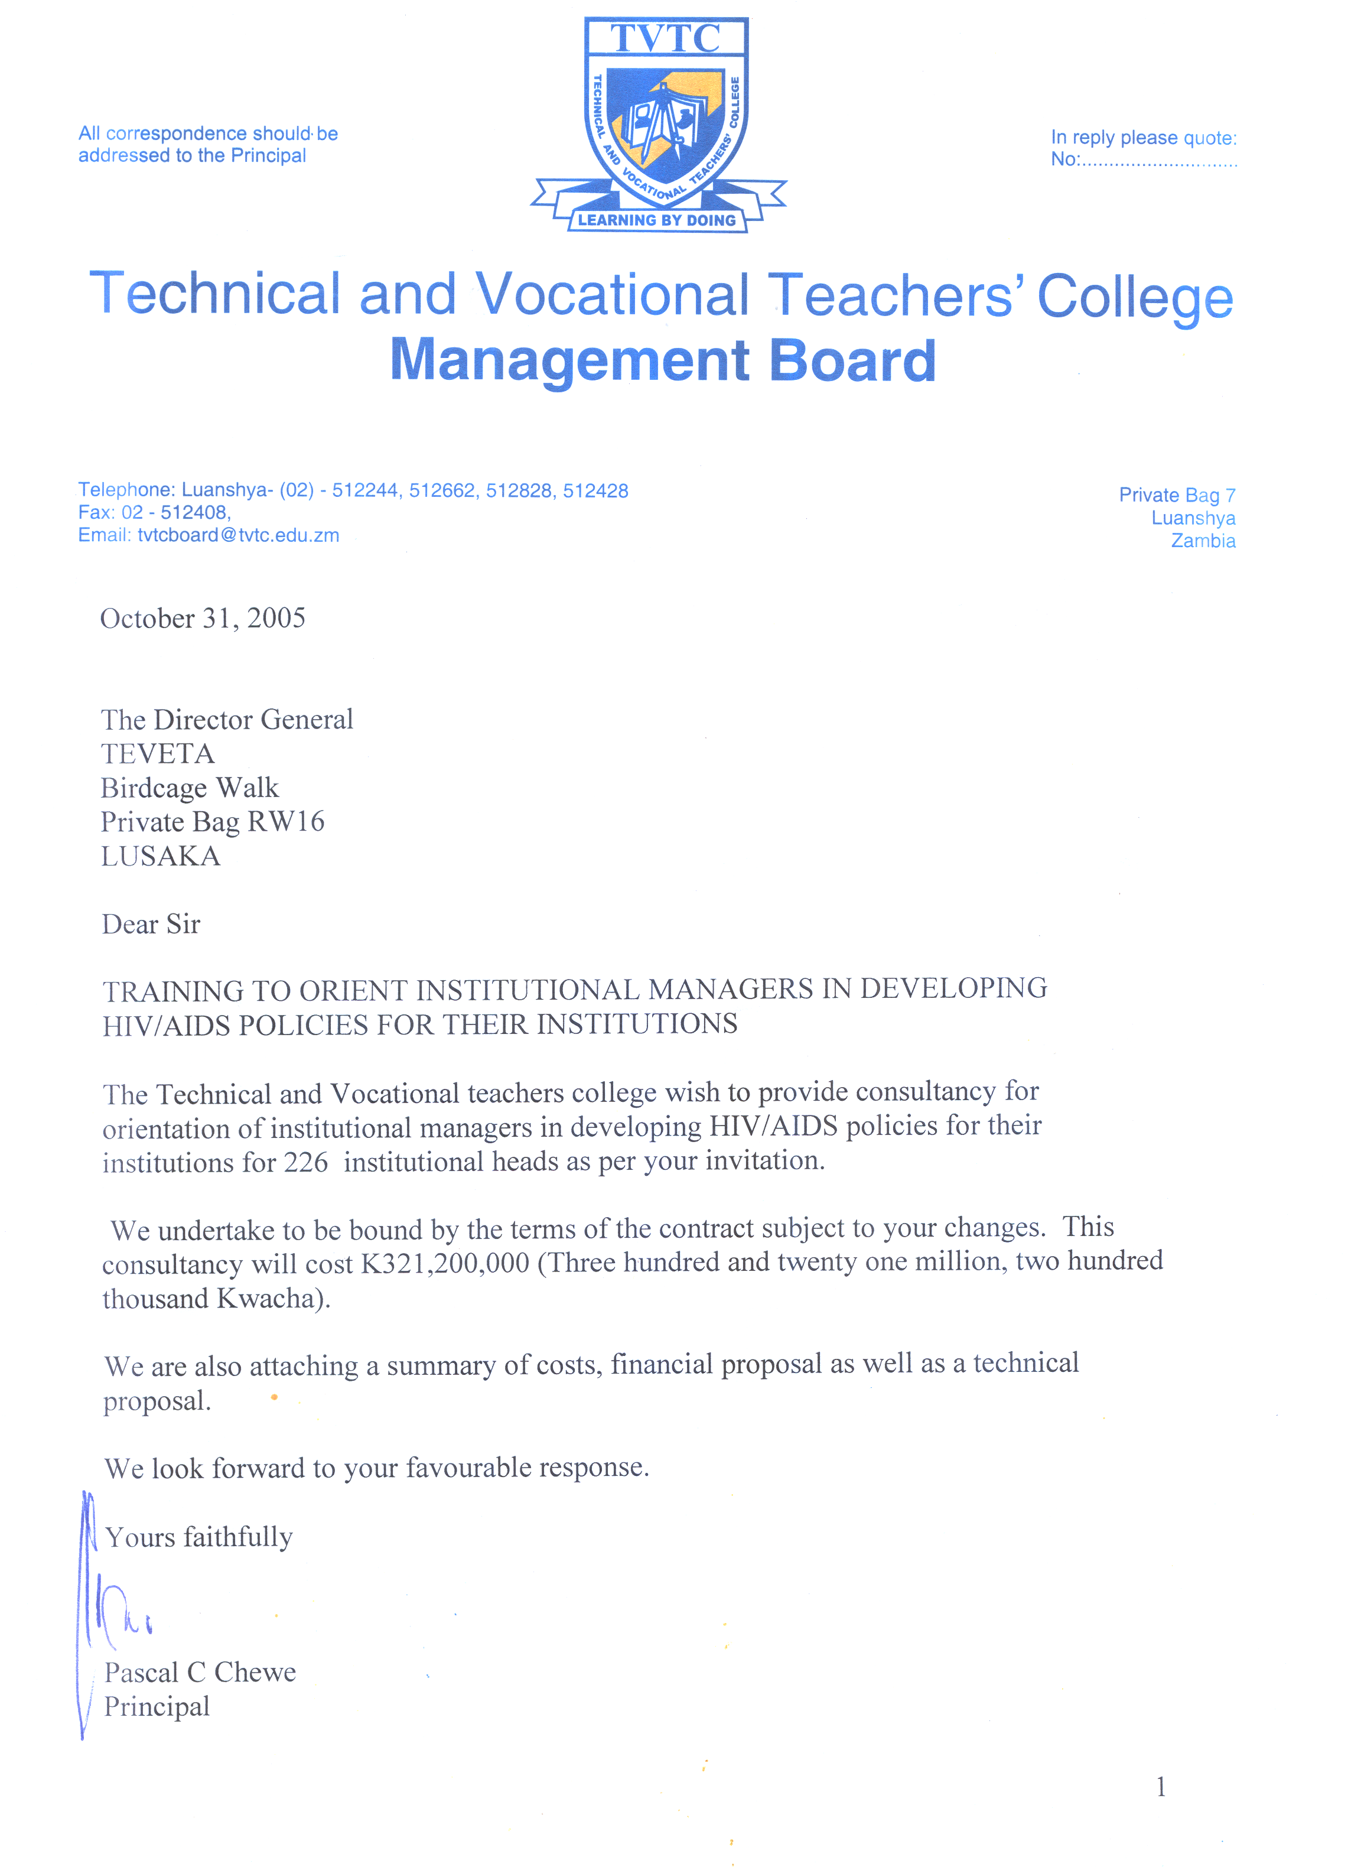

Technical and Vocational Teachers’ College

Memorandum

To: BScDTTE 09 Year 1

From: Principal

Date: 7th September, 2020

Subject: 2020 TERM 3 USER FEES

This serves to inform all students in the BScDTTE 09 class that the user fees for term 3 of 2020 will be paid as follows:

CLASSES | BScDTTE 09
 | K
Tuition fees | 3,700.00
Library fees | 150.00
General Purpose fund | 100.00
Exam fees | 1,200.00
Total | 5,150.00

You are further informed that the opening date for term 3 will be Monday 28th September, 2020 and all user fees must be paid by that date.

Please note that payment of hostel accommodation is not compulsory and is limited. However, hostel accommodation will be given on “first paid first served” basis, to those students who will pay their fees in full including K677.00 per term for accommodation.

Please further note that those who may wish to lodge at ISTEC should submit their applications in writing, indicating their contact details. Accommodation at ISTEC will also cost K777.00 per term per bed space.

Methods of payment of fees:

All fees must be deposited into the College’s bank account using the Bill Muster deposit slips at any Zanaco Bank branch throughout the country. In this regard, you are all advised to request for the bill muster deposit slips from the bank officials of any Zanaco bank branch and complete the deposit slip with all relevant details, as well as the College’s bank account details provided below:

Account name: TVTC
Account number: 0120199300141.
Bank/Branch: Zanaco – Luanshya

After making the deposit you are advised to bring your original deposit slip when you report to school for verification.

Please note that direct cash payment of fees to the College will not be accepted.

You are also being advised that should you for some reason wish to discontinue your program, please do so formally by settling any outstanding user fees before withdrawing by writing to the Principal who will then acknowledge your letter of withdraw from the College program. This is the only way that billing of your account will stop.

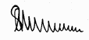

SANGSTER JERE

